CST 367/467

Michael Ruth

Homework #2

**Due: 10/19/20 (by midnight)**

For this assignment, you will need to create a Netbeans project which you will need to name using your Last name followed by your first name followed by “-Homework2” to name it. After completing the assignment, zip the project directory and turn in ***via blackboard*** by the due date.

For this database assignment, assume that I will/have created a derby database using your last name (all lowercase). I will create a database for you in my derby and we’ll use it for a couple of assignments.

Also, for this homework, I’ve attached code to set up your database and populate your tables. Please run these on your databases before beginning on your homework.

Finally, you will need to perform this work using Spring Boot (and either JPA or JBDC)

**Part I: GET endpoints**

**1. (20%) Get all employees (optional SID, optional POSITION)**

**a. If SID is present, return all employees with the given supervisor --**35446

**--**11849

**b. If POSITION is present, return all employees with the given position**

**c. If both, return all employees with the given position and given supervisor**

**d. If neither, return all employees**

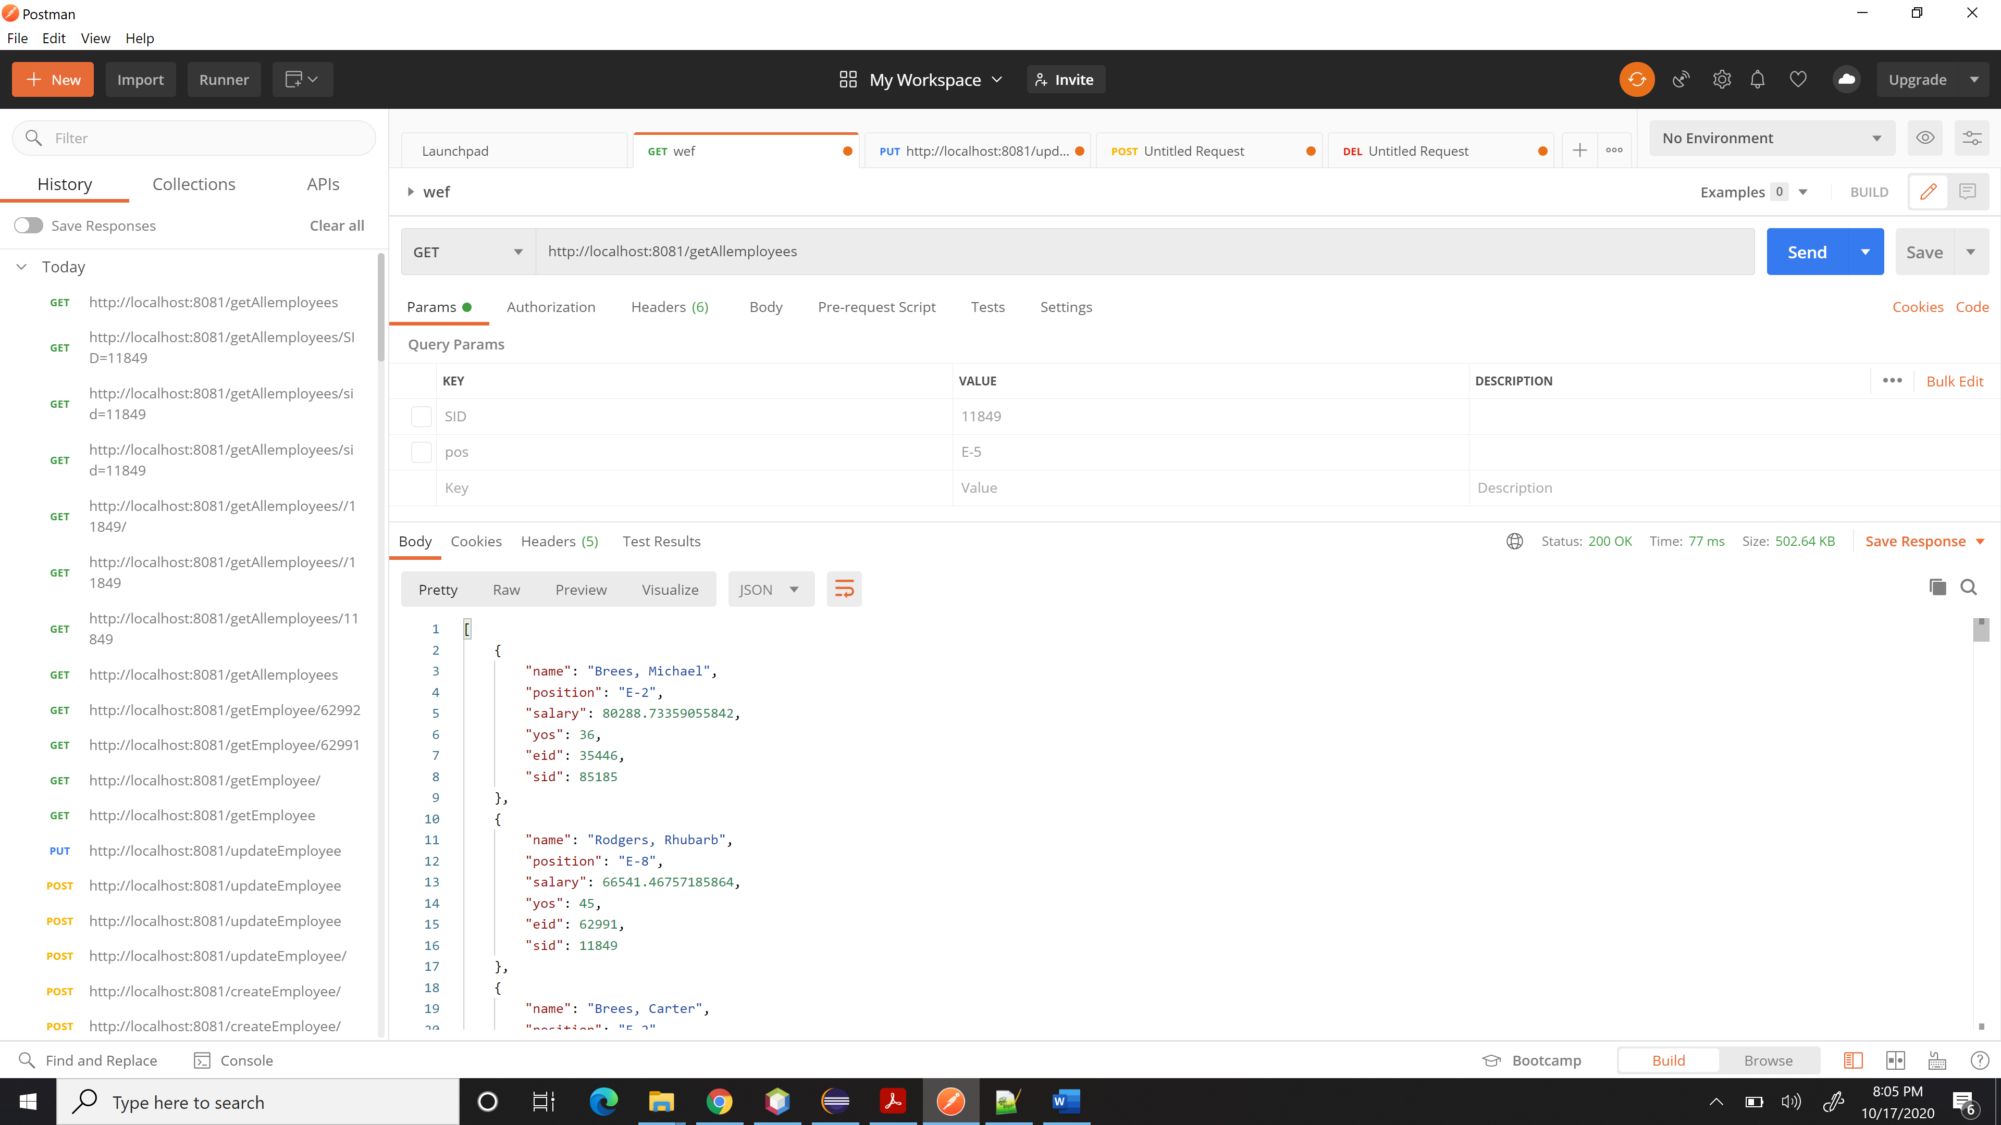

**2. (10%) Get employee with given EID**

**a. If the employee with the given EID exists, return it**

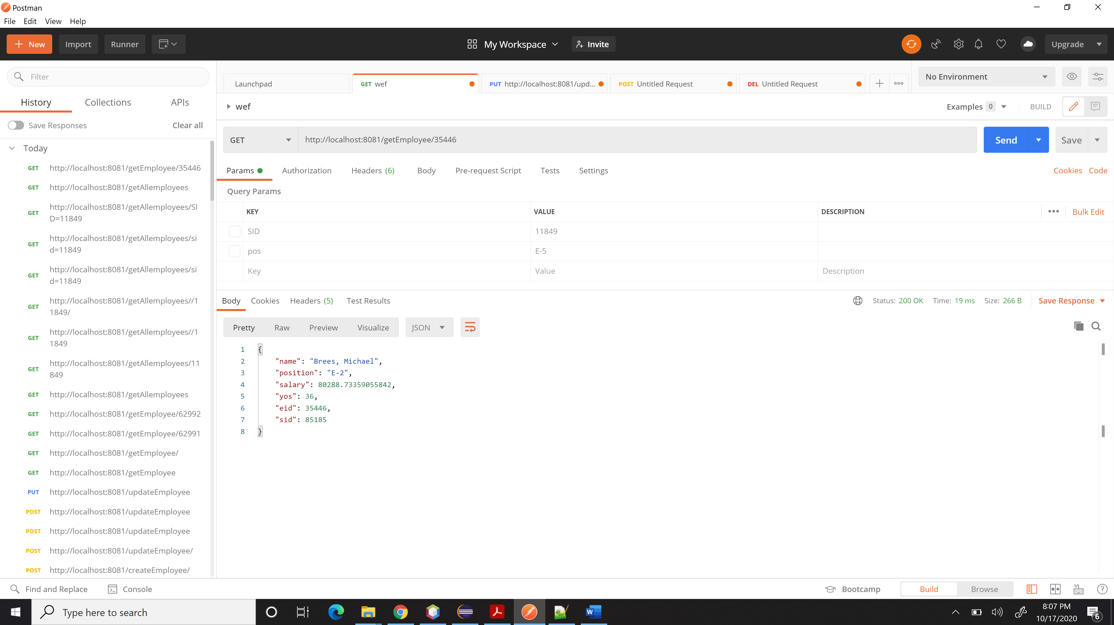

**b. Otherwise, return 404**

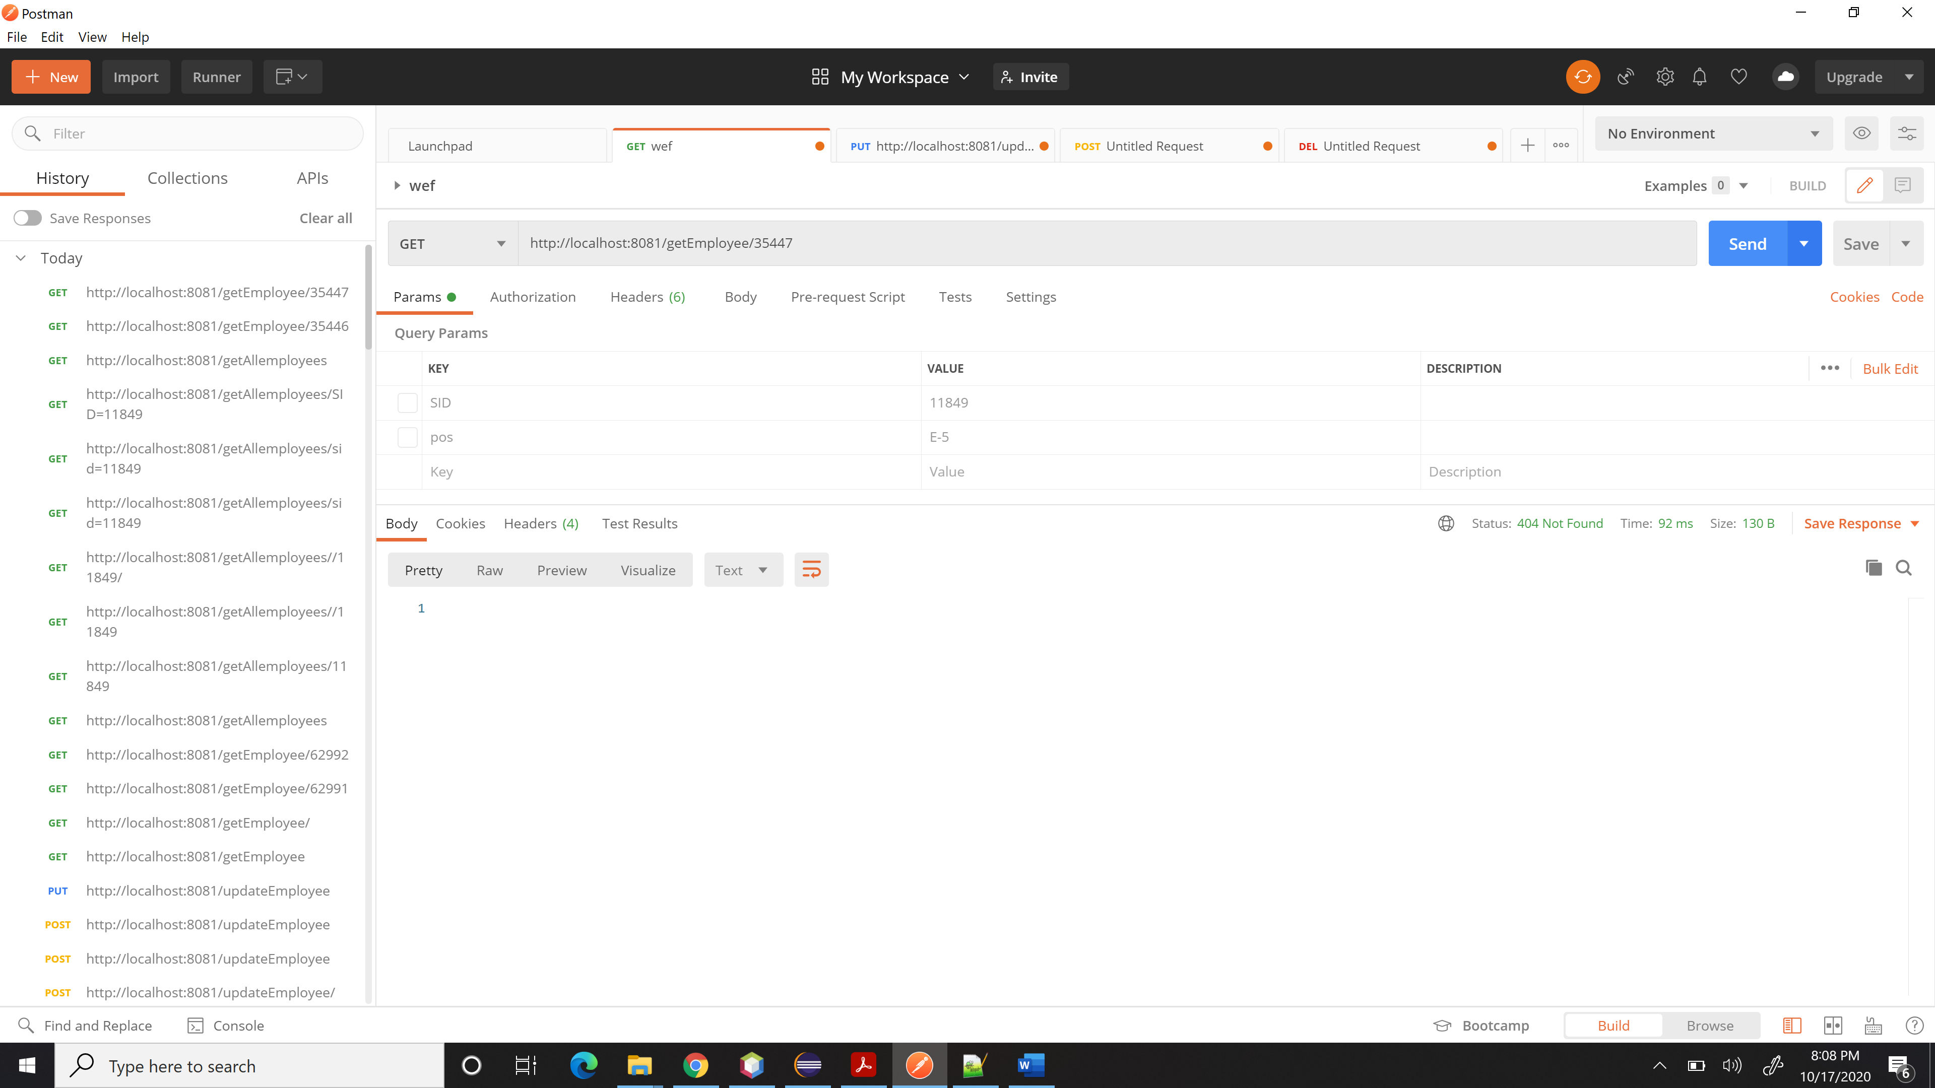

**3. (10%) Get all employees from given department (given by department)**

**a. If any employees with the given department exists, return them**

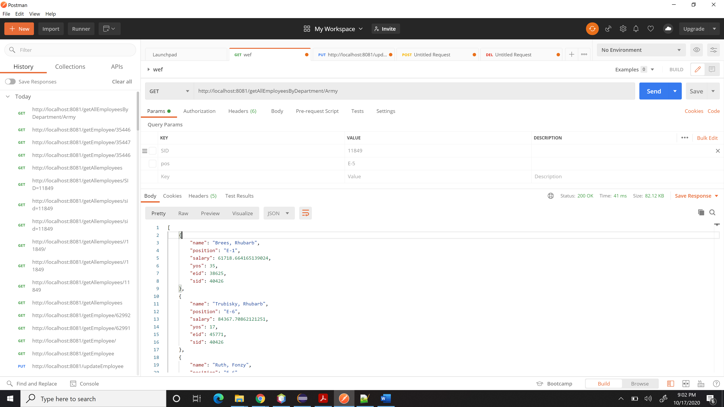

**b. Otherwise, return a 404**

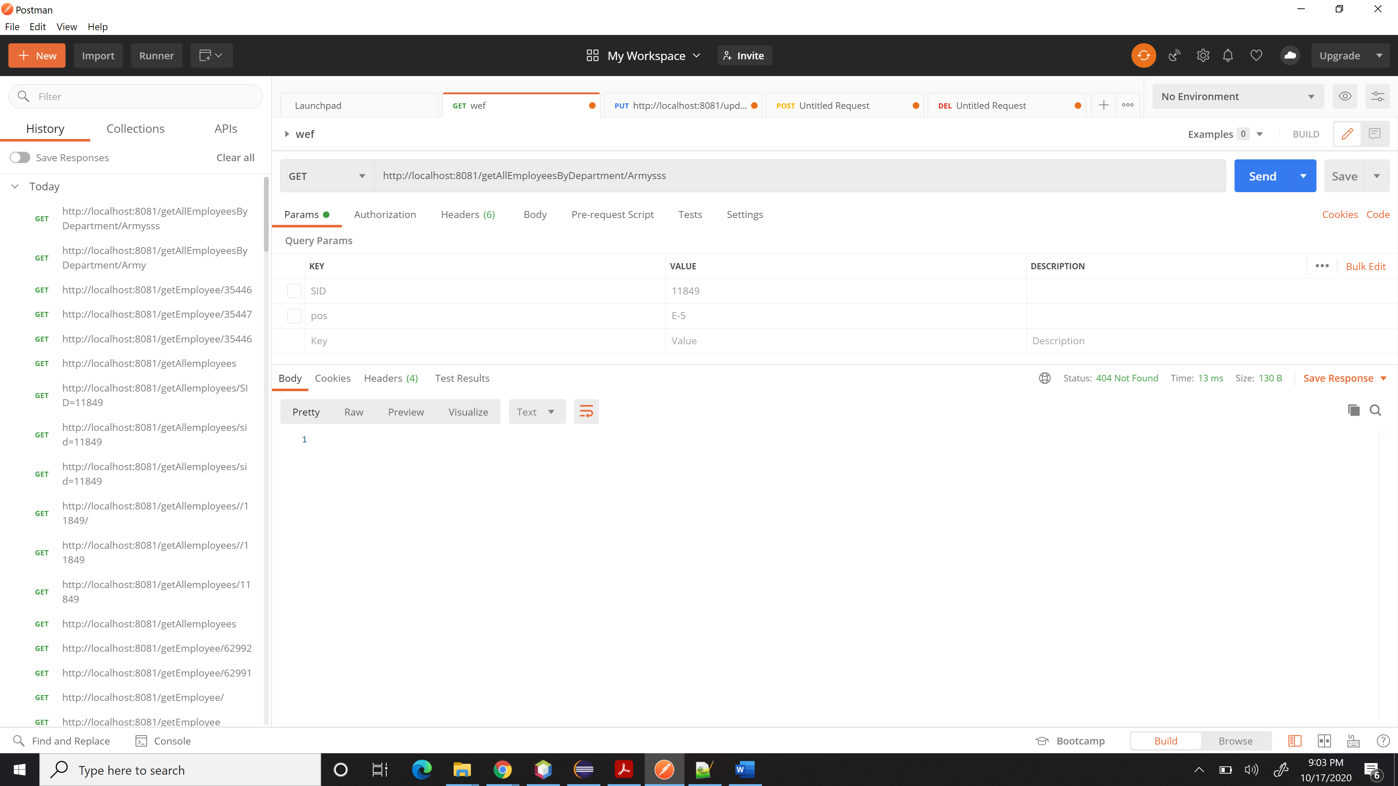

**4. (10%) Get the number of employees given a supervisor ID**

**a. If the supervisor exists, return the number, otherwise return 404**

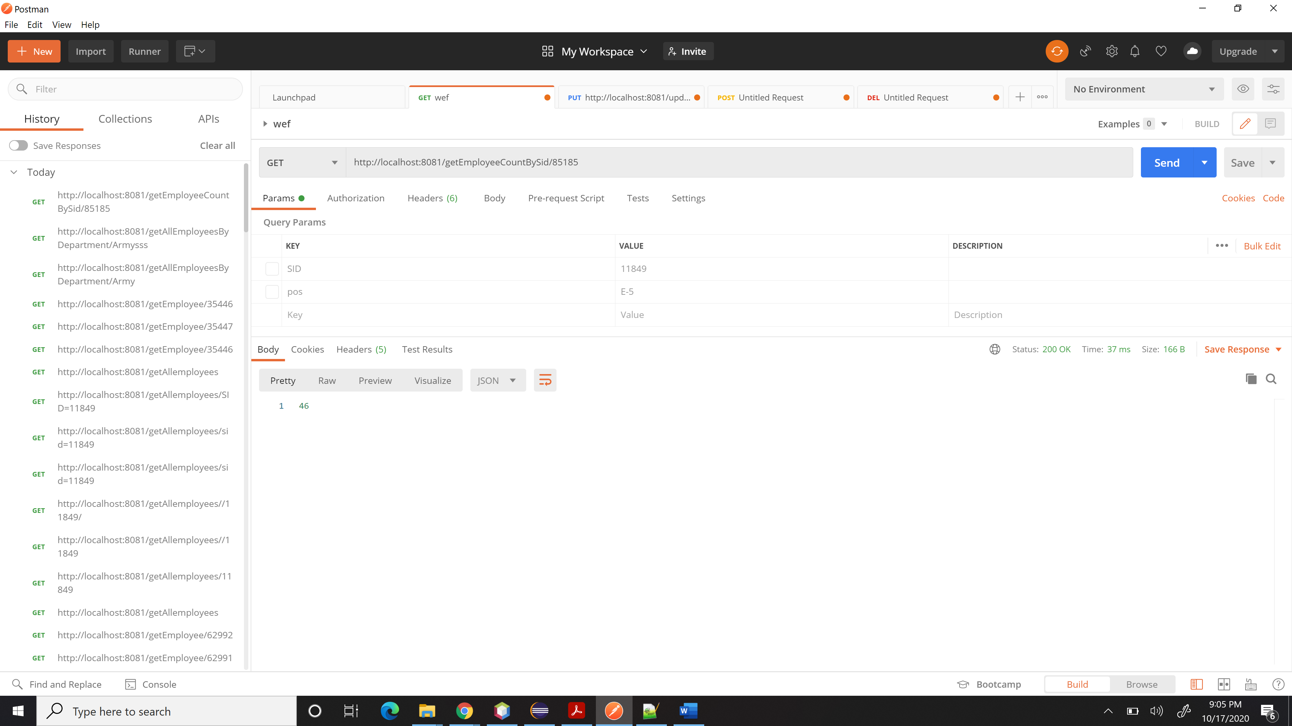

404 otherwise,

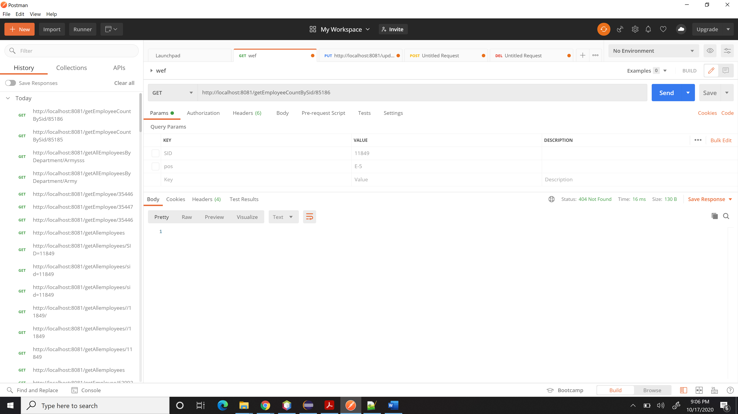

**5. (10%) Get the employee names and EIDs for all employees with over 20 years of service**

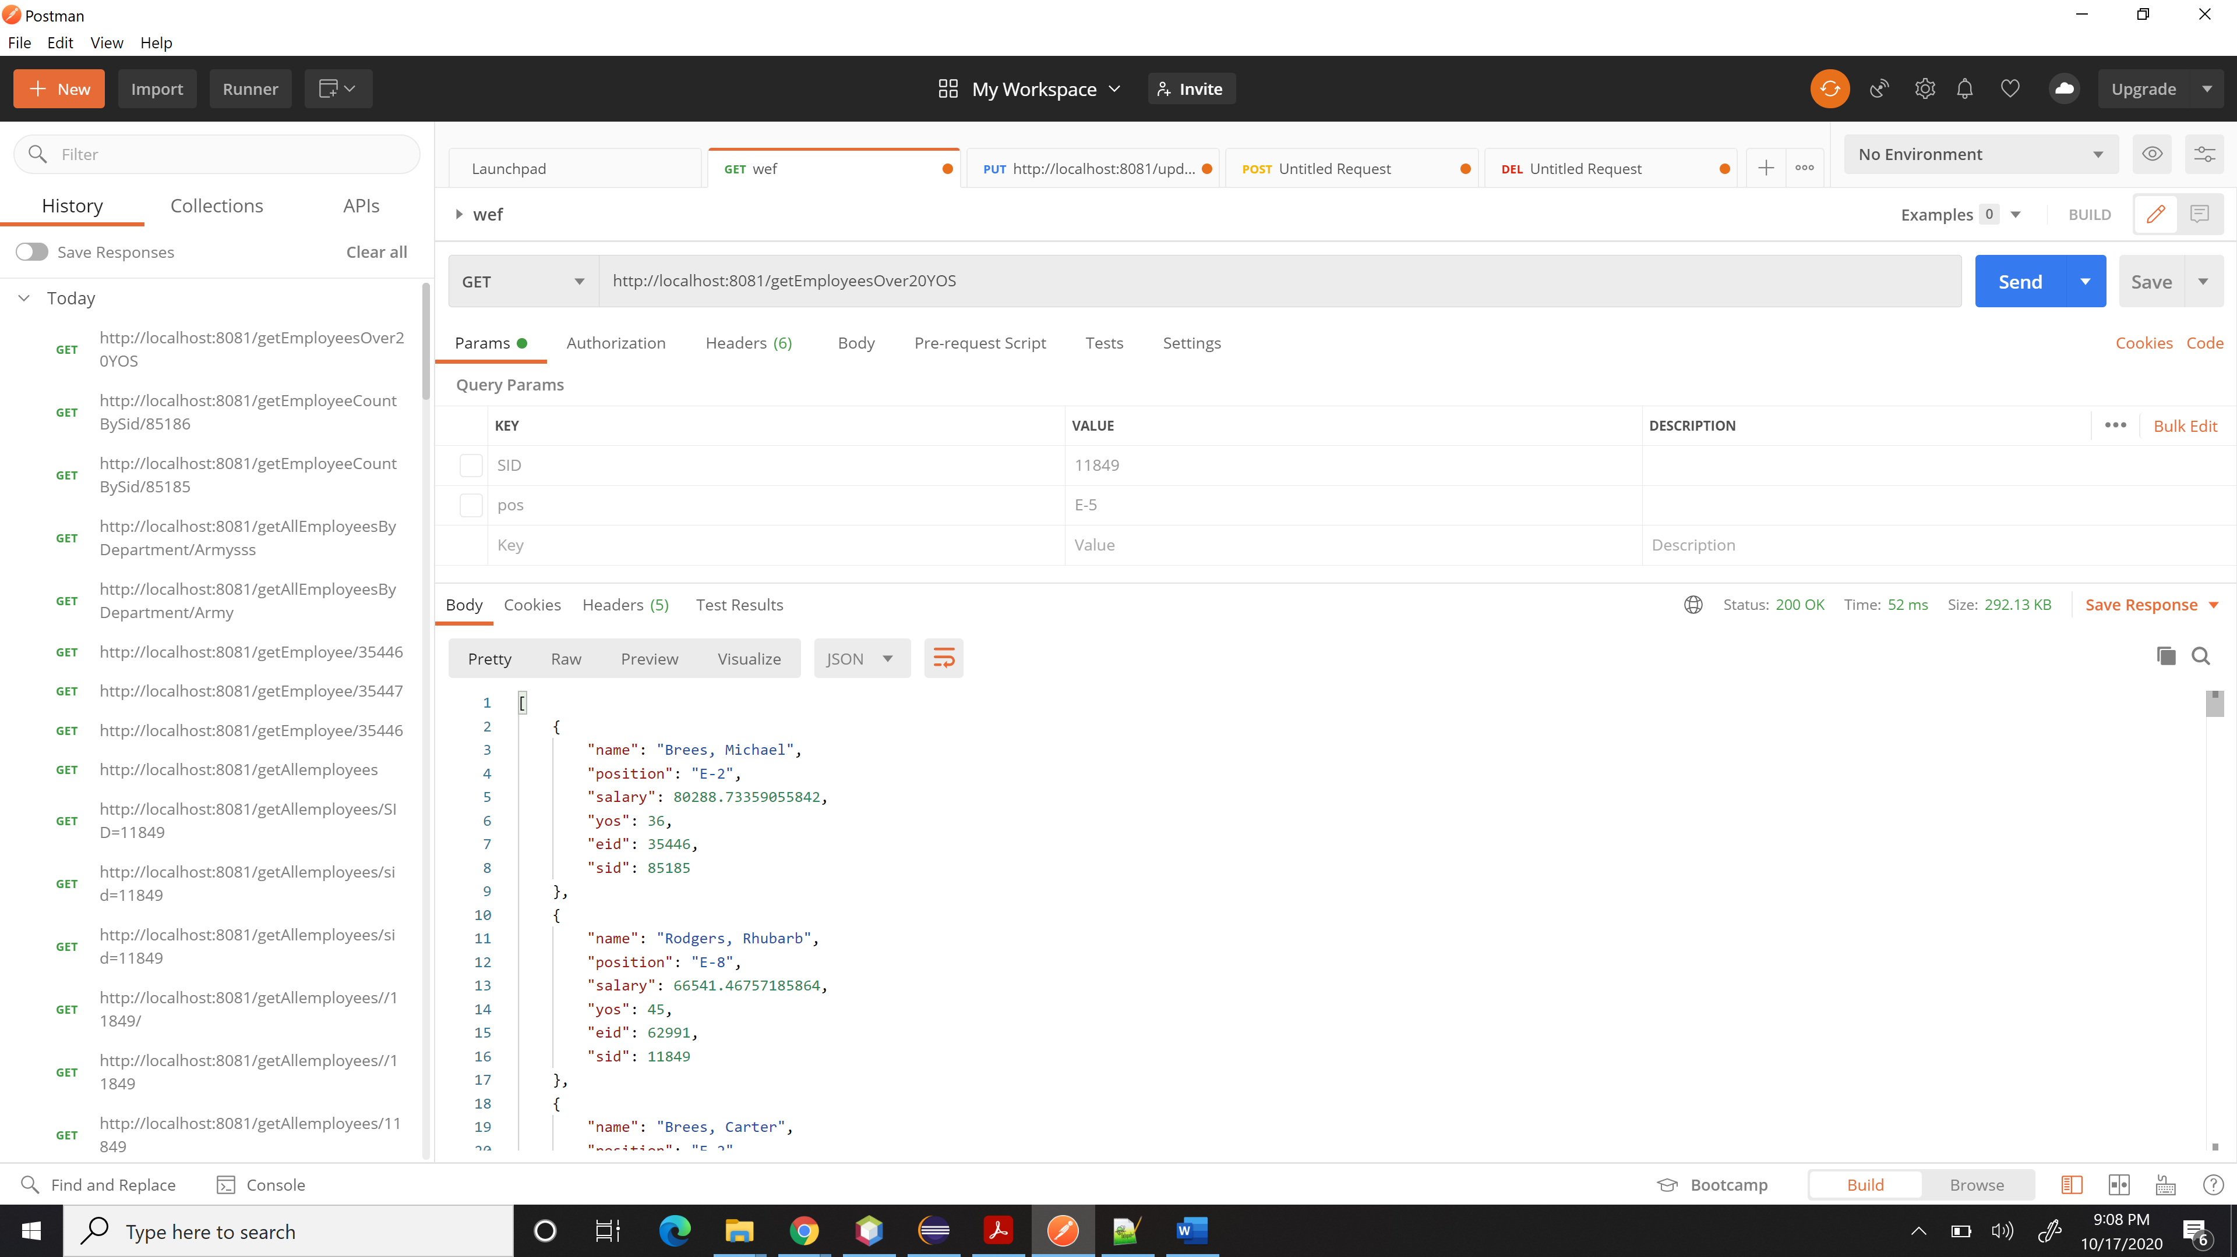

**6. (10%) Get all supervisors (optional SID)**

1. **If SID is present, return the supervisor with the given SID,**

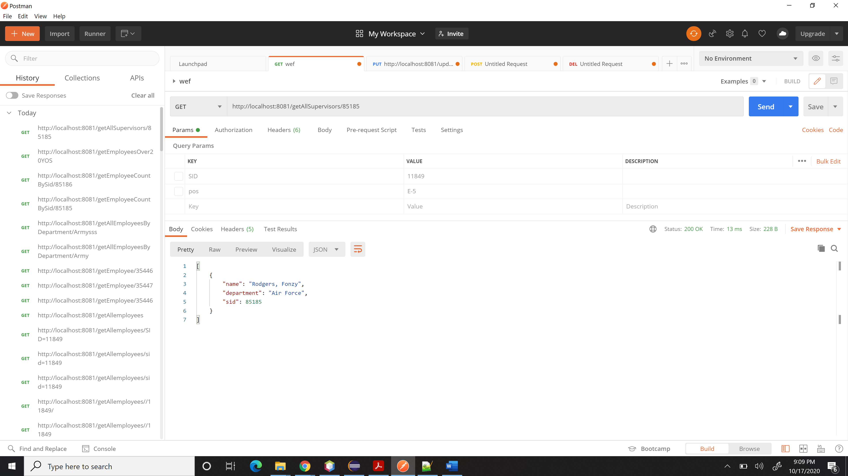

**otherwise 404**

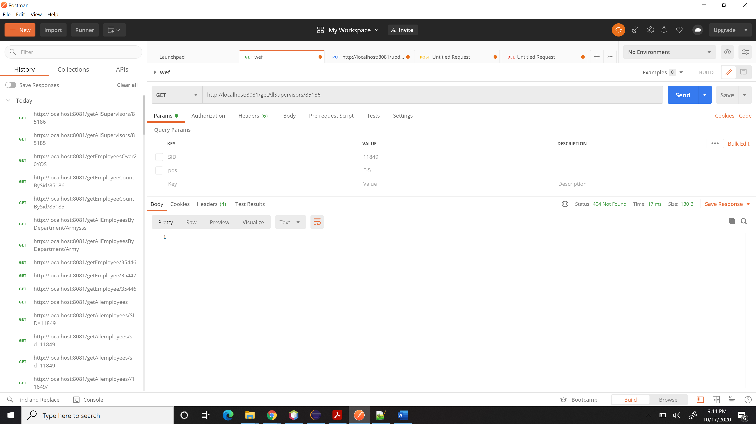

1. **If not present, return all supervisors**

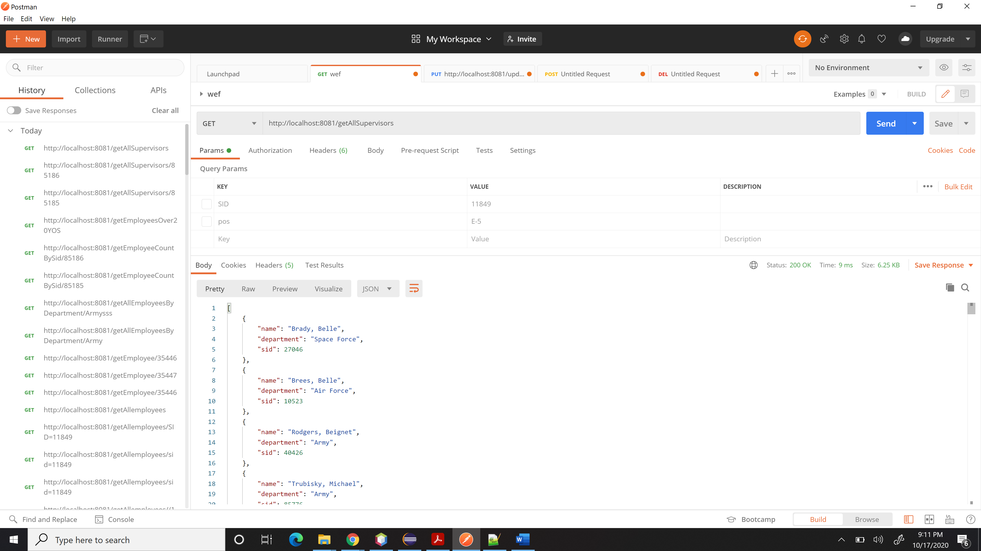

**Part II: POST endpoints**

**1. (10%) Add an employee**

**a. No duplicates allowed**

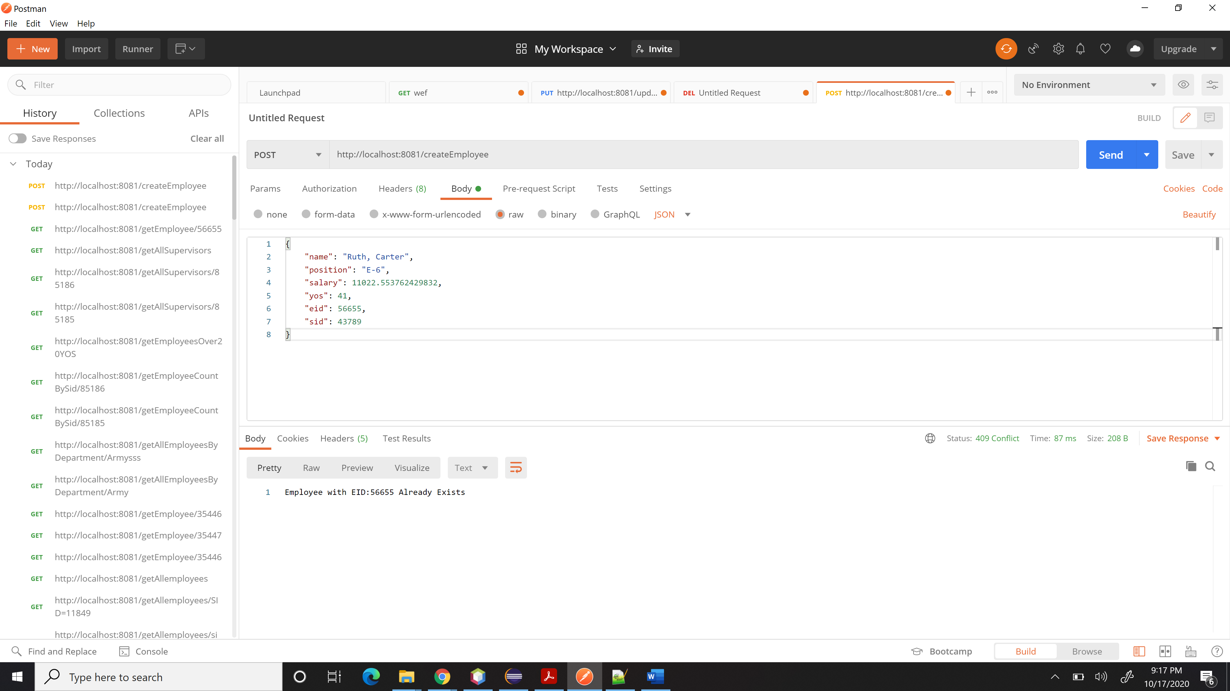

**b. Report with employee if OK, conflict otherwise**

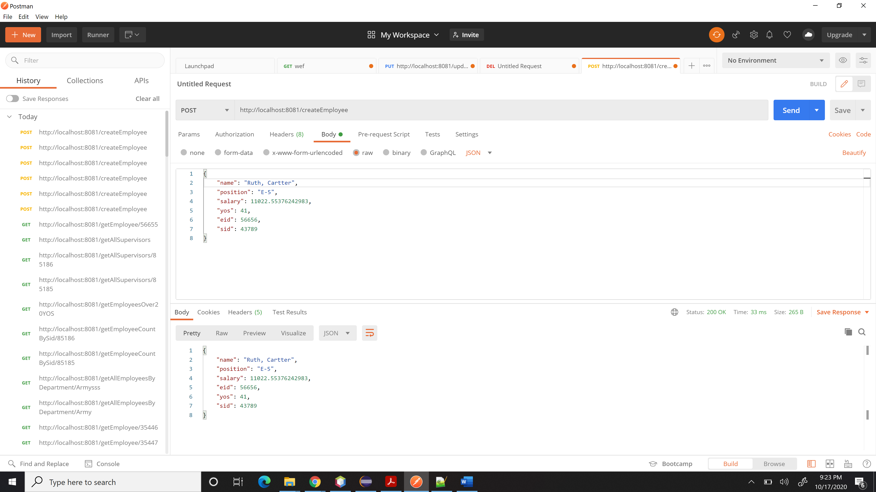

**Part III: PUT endpoints**

**1. (10%) Update an employee**

**a. No duplicates allowed**

**b. Report with employee if OK, conflict otherwise**

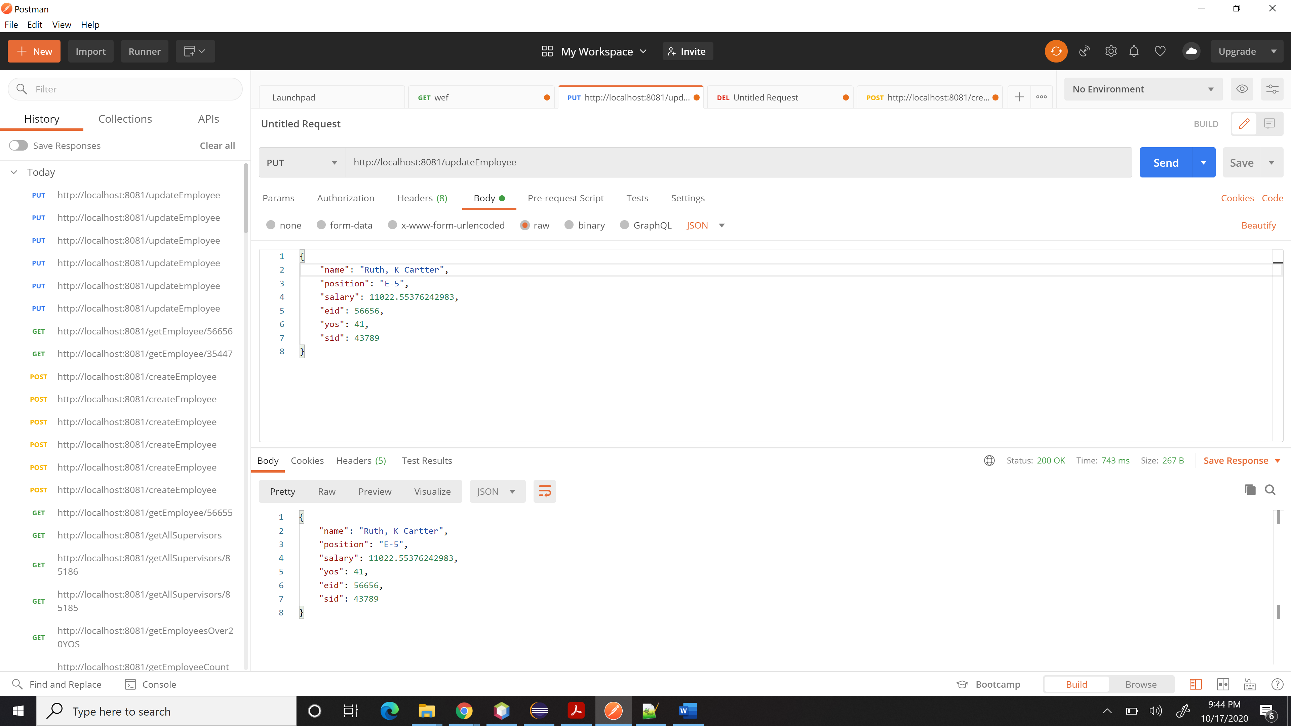

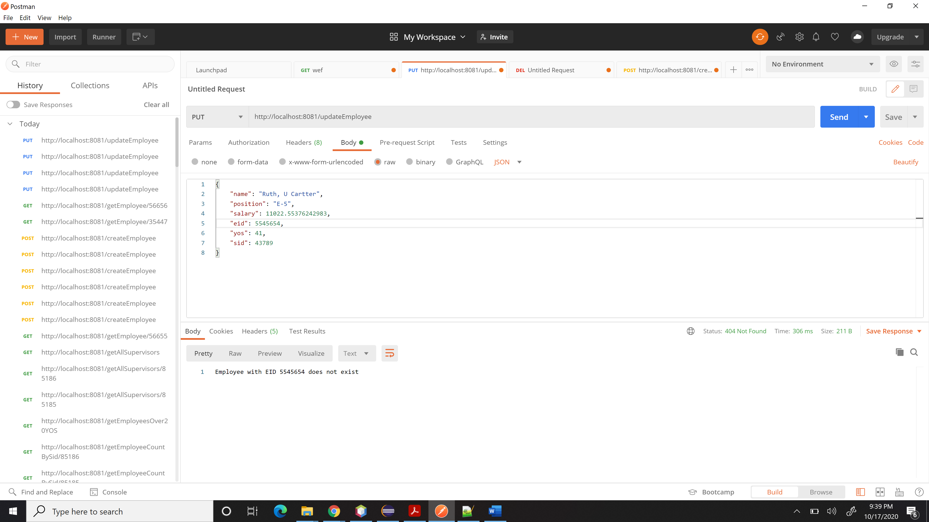

**Part IV: DELETE endpoints**

**1. (5%) Delete employee**

**a. Report with employee if OK, 404 otherwise**

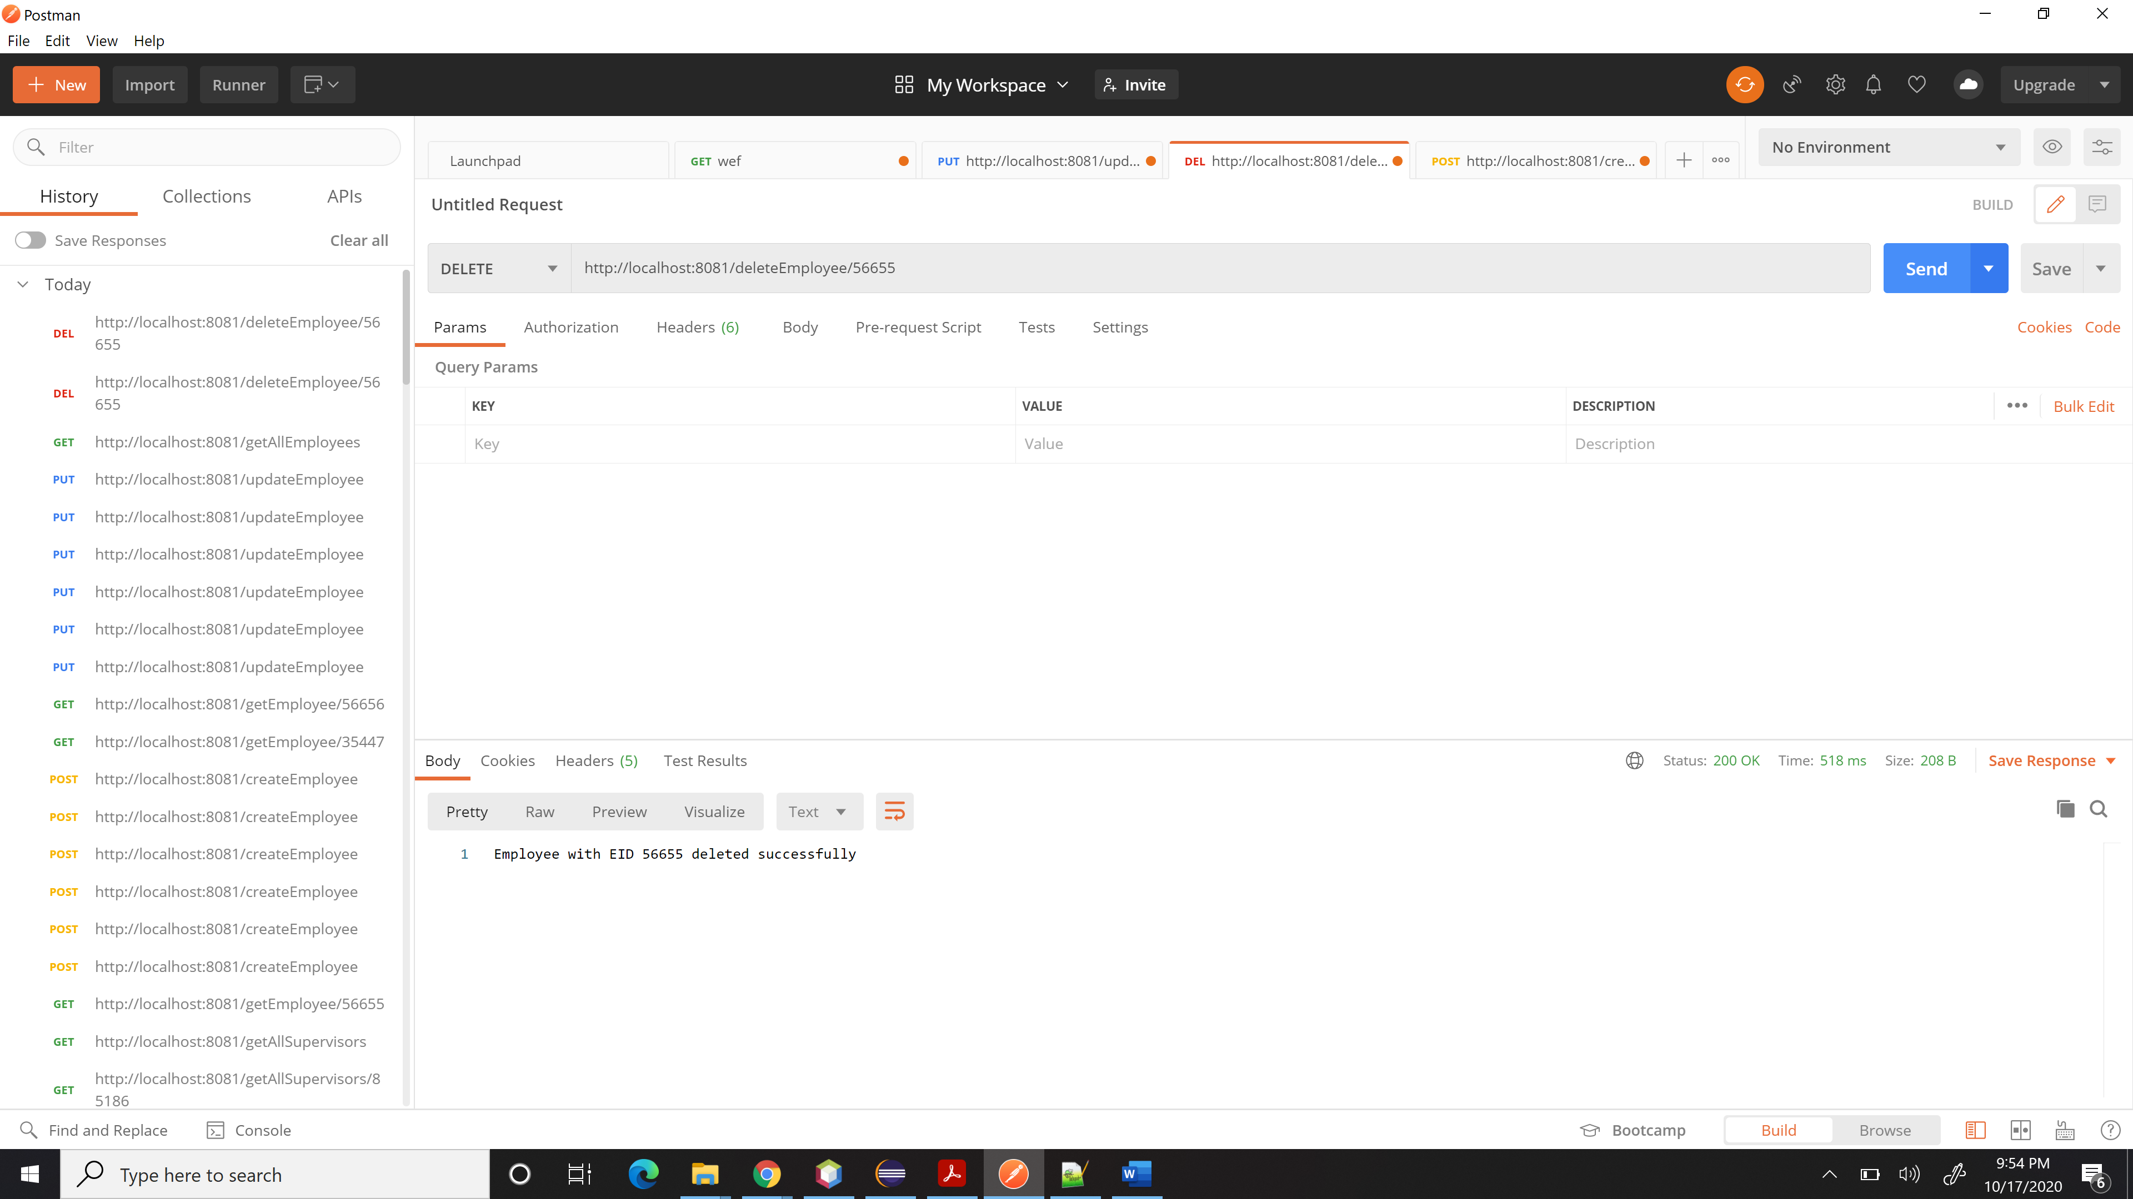

Deleting the Employee again to check if it reports 404:

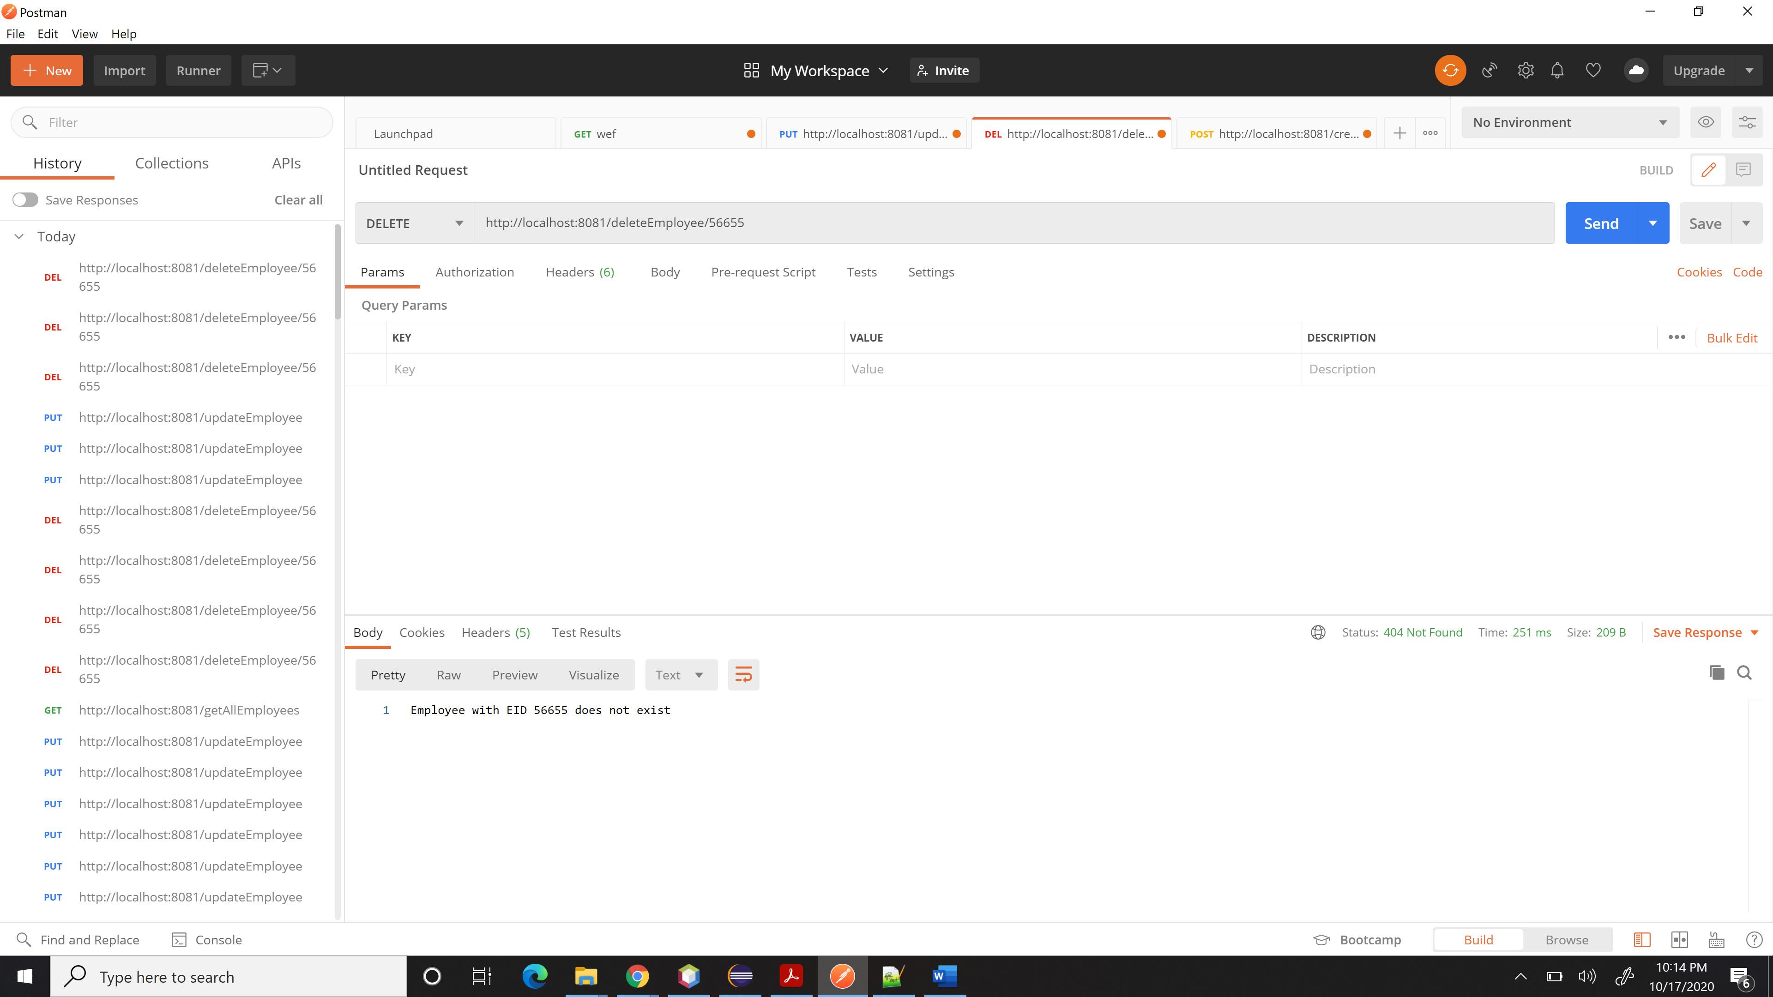

**Part V: Error**

**(5%) Respond with error objects that include a message to the user indicating what went wrong.**

**GRADUATE STUDENTS ONLY (UG may do for extra credit)**

**You will work on some additional GET endpoints:**

**1. (20%) Create a summary of the salaries grouped by department (summary should include department name, sum, count, and average)**

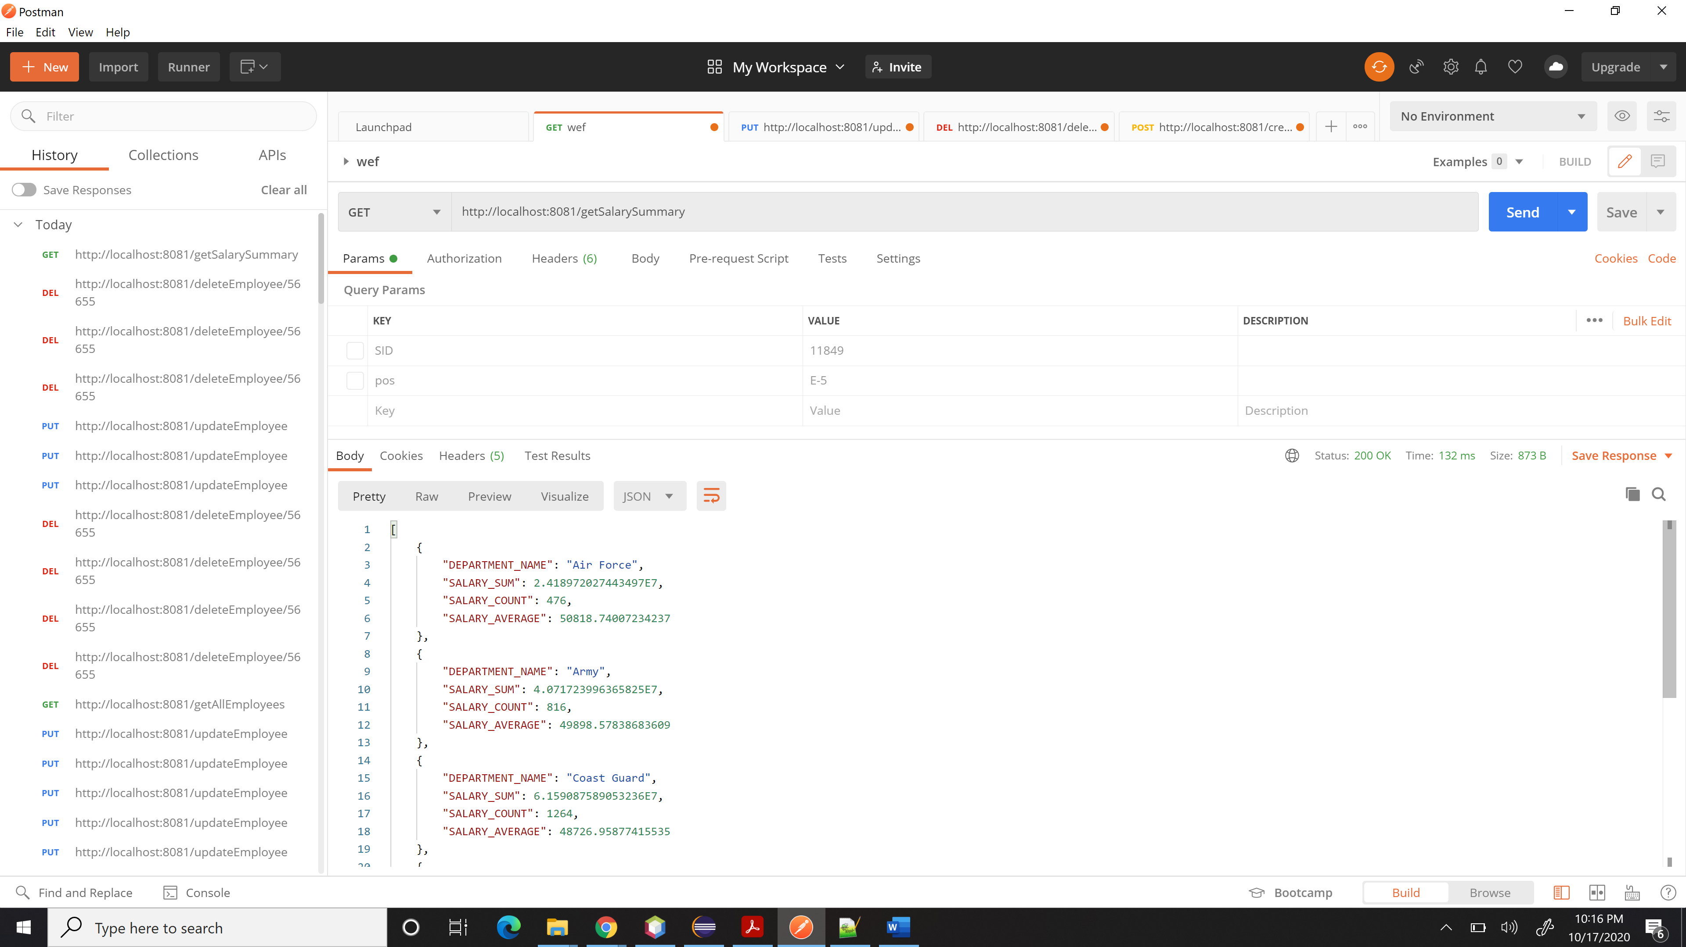

**2. (30%) Create the endpoints necessary to manage supervisors (delete, update, put).**

1. **Post Supervisor (Create)**

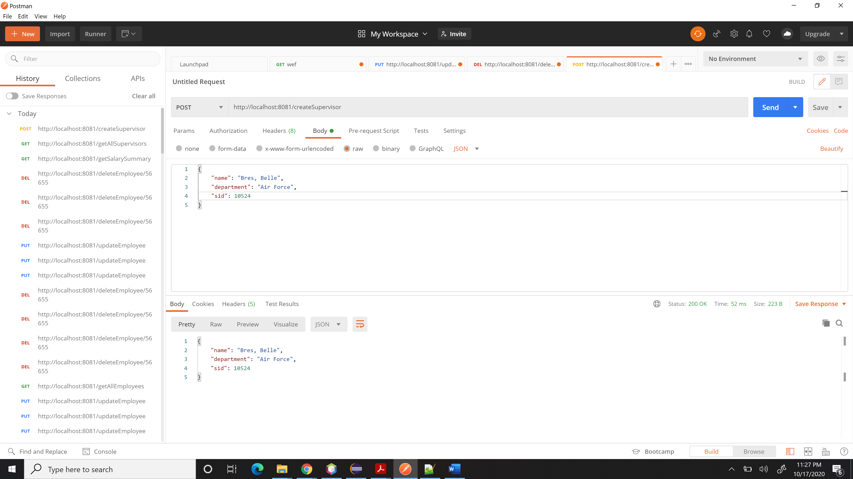

**Conflict if already exists:**

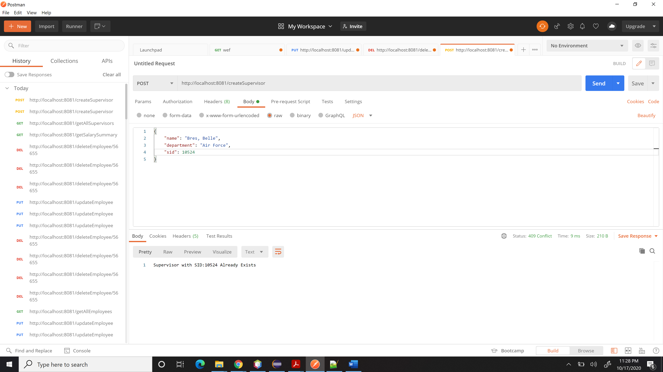

1. **Put Supervisor (Update)**

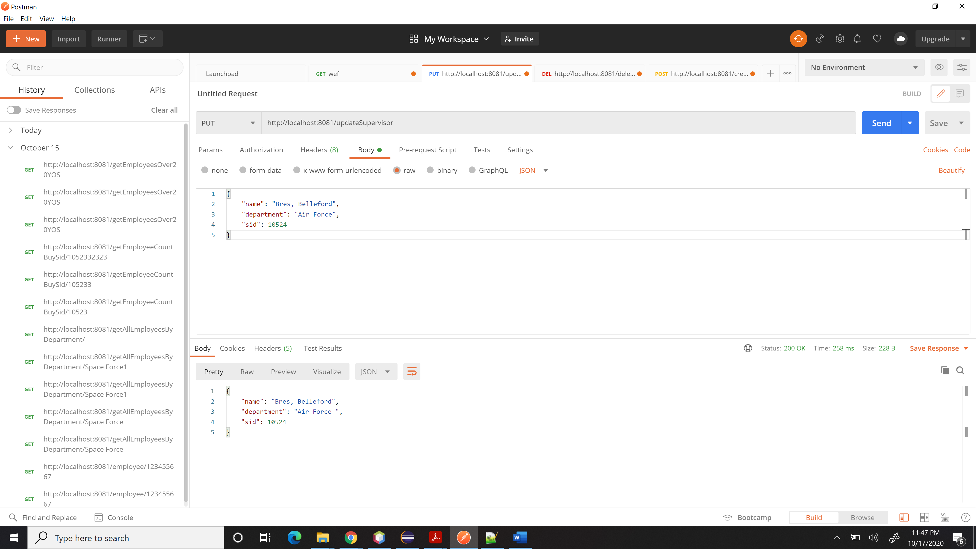

Conflict, if the Supervisor does not exist

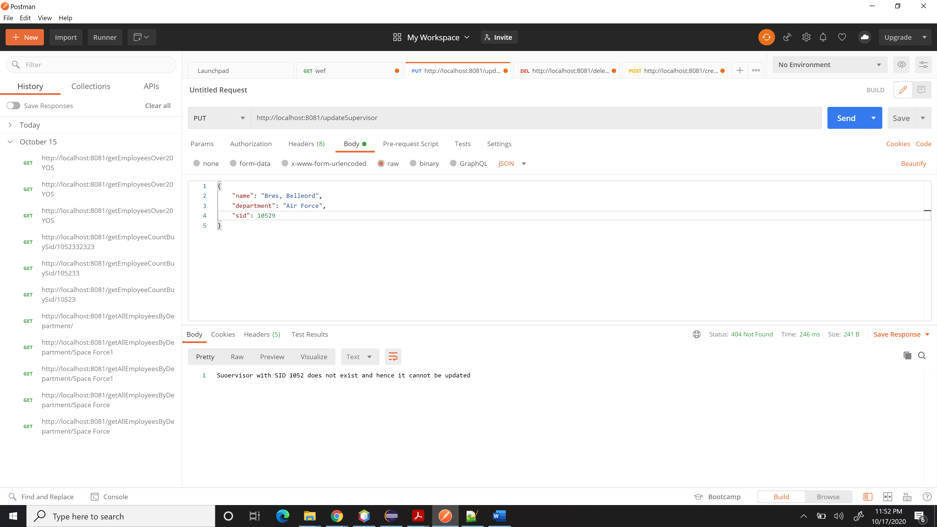

1. Delete Supervisor:

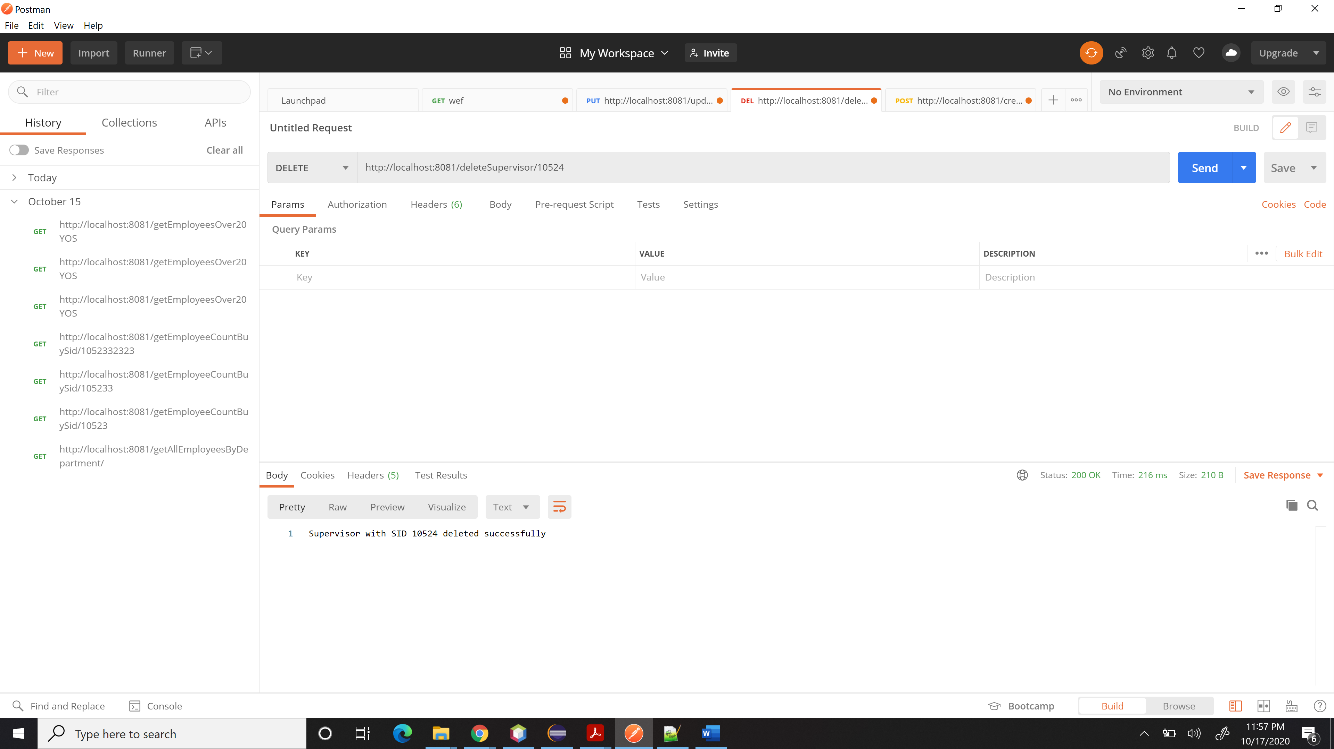

Deleting the same Supervisor again:

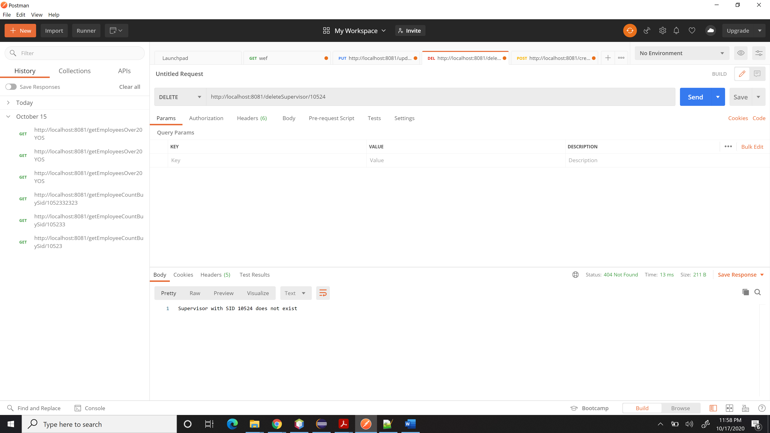

**Note:**

• If the project or the zipped file is NOT named correctly, I will take **10 points** off the total score.

• If the files within the project are named incorrectly, I will take **10 points** off the total score.

• If the db is named incorrectly, I will take **10 points off** the total score.

• If the project doesn’t contain sufficient comments, I will take **10 points** off the total score.

• This is an individual assignment and what you turn in should represent only your work.

• Do NOT try to do this last minute!